

Introduction to Database Systems
Pharmacy Inventory System

instructor: Ashraf Hendam
Team Members:
- Samaa Khaled : 202401280
- Mariam Mohamed : 202400733
- Rahma Ali : 202400365
- Nadeen Ayman : 202300234

Contact info:
- s-nadeen.mahmoud@zewailcity.edu.eg

1. Introduction
Pharmacy Inventory System is a web-based Pharmacy Management System designed to automate and streamline the management of medicines, suppliers, and customer transactions in small to medium-sized pharmacies. The system eliminates manual errors in stock handling, provides real-time updates after every sale, sends low-stock and expiry alerts, and maintains detailed records of supplier transactions and customer purchases. It ensures better inventory control, regulatory compliance, and improved customer service through accurate tracking and digital record-keeping.

2. Design Phase Recap
1. Final ER Diagram
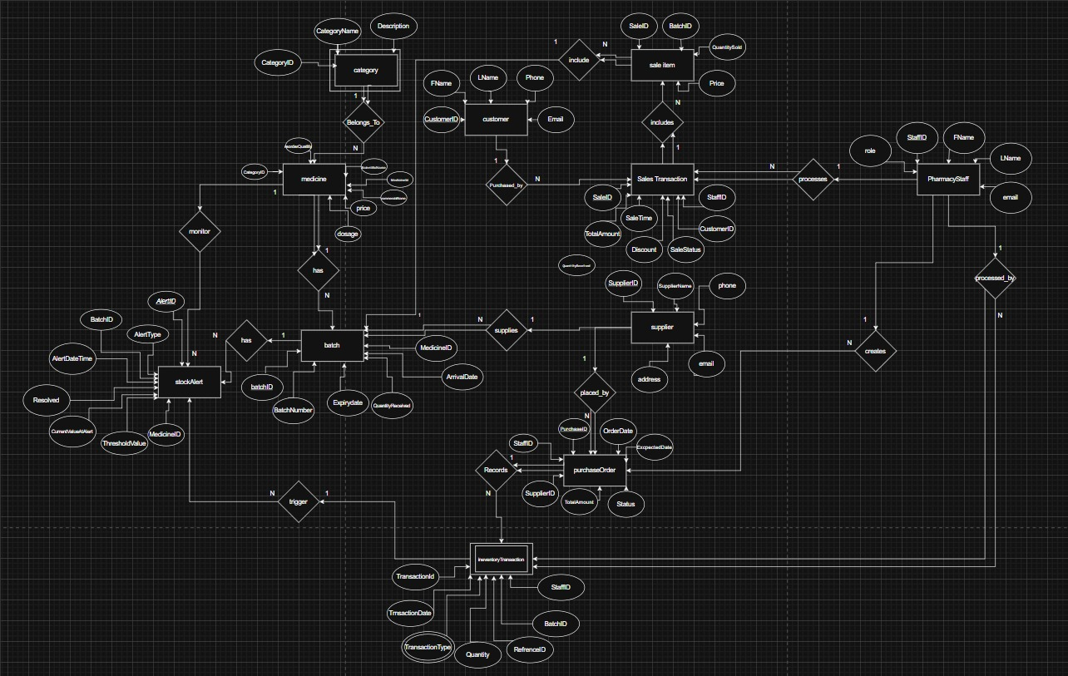

2.Data Base Schema
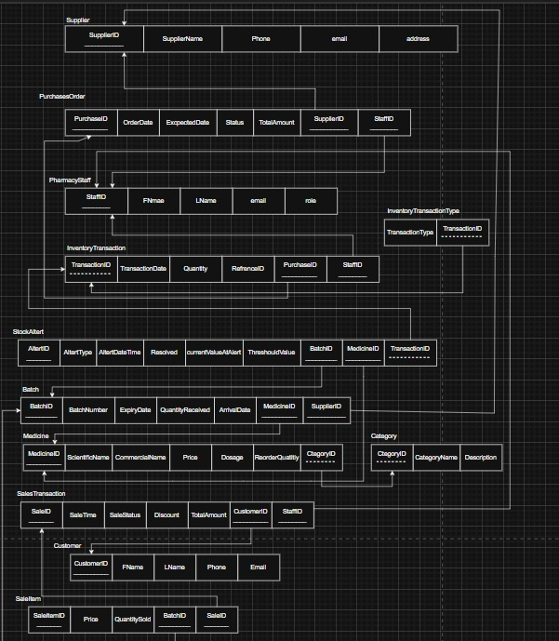

3 . Key Relationships
- Medicine → Category (Many-to-One)
- Medicine → Batch (One-to-Many)
- Medicine → StockAlert (One-to-Many)
- Supplier → Batch (One-to-Many)
- Supplier → PurchaseOrder (One-to-Many)
- Batch → SaleItem (One-to-Many)
- Batch → StockAlert (One-to-Many)
- PharmacyStaff → SaleTransaction (One-to-Many)
- PharmacyStaff → InventoryTransaction (One-to-Many)
- PharmacyStaff → PurchaseOrder(One-to-Many)
- Customer → SaleTransaction (One-to-Many)
- SaleTransaction → SaleItem (One-to-Many)
- PurchaseOrder → InventoryTransaction (One-to-Many)
- InventoryTransaction → StockAlert (One-to-Many)

4. List of Relationships and Descriptions
Relationship | Between Entities | Description
Supplies | Supplier → Medicine | Supplier can supply many medicines
BelongsTo | Medicine → Category | Each medicine belongs to one category

Has | Medicine → Batch | Each medicine can have multiple batches
monitor | Medicine → StockAlert | Each medicine can generate multiple stock alerts
Supplies | Supplier → Batch | Each supplier can supply multiple batches
Placed_by | Supplier → PurchaseOrder | Each supplier can receive multiple purchase orders
include | Batch → SaleItem | Each batch can be used in multiple sale items
Triggers | InventoryTransaction → StockAlert | Each inventory transaction can create stock alerts
has | Batch → StockAlert | Each batch can trigger expiry alerts

3. Implementation Phase
4.1 Technology Used:
Frontend : HTML, CSS
Backend: c#.Net
Database: MySQL Server
Tools: Visual Studio, MySqlServer.
4.2 Database Implementation
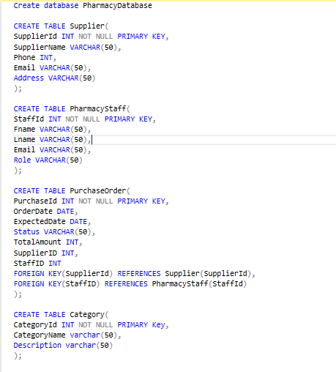

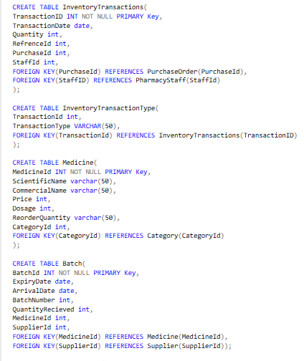

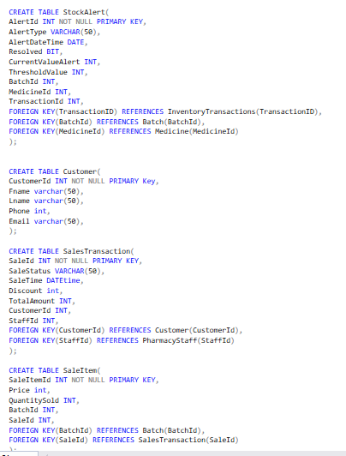

APP QUERIES:
--1 STAFF
SELECT *
FROM PharmacyStaff
WHERE Email = 'ahmed.ali@pharmacy.com';

SELECT * FROM PharmacyStaff WHERE Role = 'Pharmacist';
SELECT * FROM PharmacyStaff WHERE Role = 'Inventory Manager';

--2 MEDICINE MANAGEMENT
SELECT m.MedicineID, m.CommercialName, m.ScientificName, m.Price, m.Dosage, m.ReorderQuantity, c.CategoryName
FROM Medicine m
JOIN Category c ON m.CategoryID = c.CategoryID
WHERE m.CommercialName LIKE '%Panadol%' OR m.ScientificName LIKE '%Paracetamol%';

SELECT m.*, c.CategoryName
FROM Medicine m
JOIN Category c ON m.CategoryID = c.CategoryID
WHERE c.CategoryName = 'Analgesics';

SELECT m.MedicineID, m.CommercialName, m.ScientificName,
SUM(b.QuantityRecieved) - COALESCE(SUM(si.QuantitySold), 0) AS CurrentStock, m.ReorderQuantity
FROM Medicine m
LEFT JOIN Batch b ON m.MedicineID = b.MedicineID
LEFT JOIN SaleItem si ON b.BatchID = si.BatchID
GROUP BY m.MedicineID, m.CommercialName, m.ScientificName, m.ReorderQuantity;

INSERT INTO Medicine (MedicineID, ScientificName, CommercialName, Price, Dosage, ReorderQuantity, CategoryID)
VALUES (31000, 'NewMedicine', 'BrandName', 100.00, 500, 50, 1);

UPDATE Medicine SET Price = 22.50 WHERE MedicineID = 1;

--3 INVENTORY MANAGEMENT
SELECT m.MedicineID, m.CommercialName, COALESCE(SUM(b.QuantityRecieved), 0) - COALESCE(SUM(si.QuantitySold), 0) AS CurrentStock
FROM Medicine m
LEFT JOIN Batch b ON m.MedicineID = b.MedicineID
LEFT JOIN SaleItem si ON b.BatchID = si.BatchID
GROUP BY m.MedicineID, m.CommercialName;

SELECT m.MedicineID, m.CommercialName,
SUM(b.QuantityRecieved) - COALESCE(SUM(si.QuantitySold), 0) AS CurrentStock,
m.ReorderQuantity
FROM Medicine m
LEFT JOIN Batch b ON m.MedicineID = b.MedicineID
LEFT JOIN SaleItem si ON b.BatchID = si.BatchID
GROUP BY m.MedicineID, m.CommercialName, m.ReorderQuantity
HAVING (SUM(b.QuantityRecieved) - COALESCE(SUM(si.QuantitySold), 0)) < m.ReorderQuantity;

SELECT b.BatchID, m.CommercialName, b.ExpiryDate, b.BatchNumber,
b.QuantityRecieved - COALESCE(SUM(si.QuantitySold), 0) AS RemainingQuantity
FROM Batch b
JOIN Medicine m ON b.MedicineID = m.MedicineID
LEFT JOIN SaleItem si ON b.BatchID = si.BatchID
WHERE b.ExpiryDate BETWEEN CAST(GETDATE() AS DATE)
AND DATEADD(DAY, 30, CAST(GETDATE() AS DATE))
GROUP BY b.BatchID, m.CommercialName, b.ExpiryDate, b.BatchNumber, b.QuantityRecieved;

INSERT INTO Batch (BatchID, ExpiryDate, ArrivalDate, BatchNumber, QuantityRecieved, MedicineID, SupplierID)
VALUES (131, '2026-12-31', CAST(GETDATE() AS DATE), 50, 150, 1, 1);

--4 SUPPLIER
SELECT * FROM Supplier ORDER BY SupplierName;

SELECT m.MedicineID, m.CommercialName, s.SupplierName
FROM Medicine m
JOIN Batch b ON m.MedicineID = b.MedicineID
JOIN Supplier s ON b.SupplierID = s.SupplierID
WHERE s.SupplierID = 1;

--5 PURCHASE ORDERS
INSERT INTO PurchaseOrder (PurchaseID, OrderDate, ExpectedDate, TotalAmount, Status, SupplierID, StaffID)
VALUES (1310, CAST(GETDATE() AS DATE), DATEADD(DAY, 7, CAST(GETDATE() AS DATE)), 4500.00, 'Pending', 1, 101);

SELECT po.*, s.SupplierName, ps.FName, ps.LName
FROM PurchaseOrder po
JOIN Supplier s ON po.SupplierID = s.SupplierID
JOIN PharmacyStaff ps ON po.StaffID = ps.StaffID
WHERE po.Status = 'Pending';

UPDATE PurchaseOrder SET Status = 'Completed' WHERE PurchaseID = 101;

--6 SALES
INSERT INTO SalesTransaction (SaleID, SaleTime, TotalAmount, Discount, SaleStatus, StaffID, CustomerID)
VALUES (13100, GETDATE(), 750.00, 50.00, 'Completed', 101, 101);

INSERT INTO SaleItem (SaleItemID, SaleID, BatchID, QuantitySold, Price)
VALUES (131, 131, 1, 3, 60.00);

SELECT st.SaleID, st.SaleTime, st.TotalAmount, st.Discount,
m.CommercialName, si.QuantitySold, si.Price,
ps.FName AS StaffFName, ps.LName AS StaffLName
FROM SalesTransaction st
JOIN SaleItem si ON st.SaleID = si.SaleID
JOIN Batch b ON si.BatchID = b.BatchID
JOIN Medicine m ON b.MedicineID = m.MedicineID
JOIN PharmacyStaff ps ON st.StaffID = ps.StaffID
WHERE st.CustomerID = 101
ORDER BY st.SaleTime DESC;

SELECT SUM(TotalAmount) AS DailyTotal, COUNT(*) AS NumberOfSales
FROM SalesTransaction
WHERE CAST(SaleTime AS DATE) = CAST(GETDATE() AS DATE)
AND SaleStatus = 'Completed';

--7 CUSTOMER MANAGEMENT
INSERT INTO Customer (CustomerID, FName, LName, Phone, Email)
VALUES (131, 'New', 'Customer', 201234597, 'new.customer@gmail.com');

SELECT * FROM Customer
WHERE FName LIKE '%Ahmed%' OR LName LIKE '%Ali%' OR Phone LIKE '%01234567%';

SELECT c.CustomerID, c.FName, c.LName, c.Email, COUNT(st.SaleID) AS TotalPurchases, SUM(st.TotalAmount) AS TotalSpent
FROM Customer c
LEFT JOIN SalesTransaction st ON c.CustomerID = st.CustomerID
GROUP BY c.CustomerID, c.FName, c.LName, c.Email
ORDER BY TotalSpent DESC;

--8 REPORTING
SELECT FORMAT(SaleTime, 'yyyy-MM') AS Month, COUNT(*) AS NumberOfSales, SUM(TotalAmount) AS TotalRevenue, AVG(TotalAmount) AS AverageSale
FROM SalesTransaction
WHERE SaleStatus = 'Completed'
GROUP BY FORMAT(SaleTime, 'yyyy-MM')
ORDER BY Month DESC;

SELECT TOP 10 m.MedicineID, m.CommercialName, SUM(si.QuantitySold) AS TotalQuantitySold, SUM(si.QuantitySold * si.Price) AS TotalRevenue
FROM Medicine m
JOIN Batch b ON m.MedicineID = b.MedicineID
JOIN SaleItem si ON b.BatchID = si.BatchID
JOIN SalesTransaction st ON si.SaleID = st.SaleID
WHERE st.SaleStatus = 'Completed'
GROUP BY m.MedicineID, m.CommercialName
ORDER BY TotalQuantitySold DESC;

SELECT s.SupplierID, s.SupplierName, COUNT(po.PurchaseID) AS TotalOrders, SUM(po.TotalAmount) AS TotalPurchased, AVG(po.TotalAmount) AS AverageOrderValue
FROM Supplier s
LEFT JOIN PurchaseOrder po ON s.SupplierID = po.SupplierID
GROUP BY s.SupplierID, s.SupplierName
ORDER BY TotalPurchased DESC;

SELECT m.MedicineID, m.CommercialName, m.Price,
(SUM(b.QuantityRecieved) - COALESCE(SUM(si.QuantitySold), 0)) AS CurrentStock,
(SUM(b.QuantityRecieved) - COALESCE(SUM(si.QuantitySold), 0)) * m.Price AS InventoryValue
FROM Medicine m
LEFT JOIN Batch b ON m.MedicineID = b.MedicineID
LEFT JOIN SaleItem si ON b.BatchID = si.BatchID
GROUP BY m.MedicineID, m.CommercialName, m.Price;

--9 ALERT SYSTEM
SELECT a.AlertID, a.AlertType, a.AlertDateTime, m.CommercialName, b.BatchNumber, b.ExpiryDate, a.CurrentValueAlert, a.ThresholdValue
FROM StockAlert a
JOIN Medicine m ON a.MedicineID = m.MedicineID
LEFT JOIN Batch b ON a.BatchID = b.BatchID
WHERE a.Resolved = 0
ORDER BY a.AlertDateTime DESC;

UPDATE StockAlert SET Resolved = 1 WHERE AlertID = 101;

SELECT m.MedicineID, m.CommercialName, m.ReorderQuantity,
SUM(b.QuantityRecieved) - COALESCE(SUM(si.QuantitySold), 0) AS CurrentStock
FROM Medicine m
LEFT JOIN Batch b ON m.MedicineID = b.MedicineID
LEFT JOIN SaleItem si ON b.BatchID = si.BatchID
GROUP BY m.MedicineID, m.CommercialName, m.ReorderQuantity
HAVING (SUM(b.QuantityRecieved) - COALESCE(SUM(si.QuantitySold), 0)) < m.ReorderQuantity
AND m.MedicineID NOT IN ( SELECT MedicineID
FROM StockAlert
WHERE AlertType = 'LowStock' AND Resolved = 0);

--10 INVENTORY TRANSACTIONS
INSERT INTO InventoryTransactions (TransactionID, TransactionDate, Quantity, PurchaseID, RefrenceID, StaffID)
VALUES (131, CAST(GETDATE() AS DATE), 100, 131, 1031, 101);

SELECT it.*, itt.TransactionType, ps.FName, ps.LName
FROM InventoryTransactions it
JOIN InventoryTransactionType itt ON it.TransactionID = itt.TransactionID
JOIN PharmacyStaff ps ON it.StaffID = ps.StaffID
ORDER BY it.TransactionDate DESC;

-- 11 Medicine Stock Levels, Daily Sales Summary, and Customer Purchase Overview
SELECT
m.MedicineID,
m.CommercialName,
m.ScientificName,
m.Price,
m.ReorderQuantity,
SUM(b.QuantityRecieved) - COALESCE(SUM(si.QuantitySold), 0) AS CurrentStock
FROM Medicine m
LEFT JOIN Batch b ON m.MedicineID = b.MedicineID
LEFT JOIN SaleItem si ON b.BatchID = si.BatchID
GROUP BY
m.MedicineID,
m.CommercialName,
m.ScientificName,
m.Price,
m.ReorderQuantity;

SELECT
CAST(SaleTime AS DATE) AS SaleDate,
COUNT(*) AS NumberOfSales,
SUM(TotalAmount) AS TotalRevenue,
AVG(TotalAmount) AS AverageSale,
SUM(Discount) AS TotalDiscount
FROM SalesTransaction
WHERE SaleStatus = 'Completed'
GROUP BY CAST(SaleTime AS DATE);

SELECT
c.CustomerID,
c.FName,
c.LName,
c.Email,
COUNT(st.SaleID) AS TotalPurchases,
ISNULL(SUM(st.TotalAmount), 0) AS TotalSpent,
MAX(st.SaleTime) AS LastPurchaseDate
FROM Customer c
LEFT JOIN SalesTransaction st
ON c.CustomerID = st.CustomerID AND st.SaleStatus = 'Completed'
GROUP BY
c.CustomerID,
c.FName,
c.LName,
c.Email;

LOGIN PAGE:
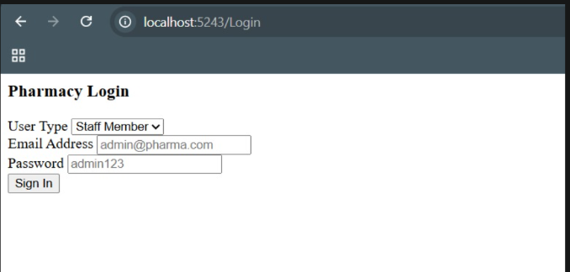

LOGOUT PAGE:



